Title: | <Door Control Module>  SW Component < WindowApp >

History
Issue status  (Index) | Maturity/Date  (draft/invalid/valid)  (dd-mmm-yyyy) | Author  Department | Check/Release  Department | Description
1.0 | Draft  03-Sep-21 | Edgar Reyes |  | WindowApp SDD

Table of Contents
1 Purpose 3
2 Definitions and abbreviations 3
3 Realization constraints and targets 4
4 SW Conceptual design 4
5 SW Component internal breakdown 4
5.1 Functional Decomposition 4
5.2 Function void init (void) 6
5.3 Function void run_WindowApp (void) 6
5.4 Function void Manual_Open (void) 7
5.5 Function void Manual_Close (void) 7
5.6 Function void Remote_Open (void) 8
5.7 Function void Remote_Close (void) 8
5.8 Function void Hw_Diagnotics (void) 8
5.9 Function void Window_Position (void) 9
5.10 Function void Obstacle_Handler (void) 9

Purpose
This text file has been created as a Software Detail Design documentation for WindowApp Software Component, based on the Software Requirements and Software Architecture (Physical and Functional) from the Door Control Module project.

Definitions and abbreviations
Definitions
IN_BETWEEN | 0x00 Windows is in between this means the window is not completely OPEN neither completely CLOSE
COMPLETELY_OPEN | 0x01 Window is Completely Open
COMPLETELY_CLOSE | 0x02 Window is Completely Close
ERROR | 0x03 Windows is on an ERROR state
WINDOW_IDLE | 0x00 Window is not moving
WINDOW_UP | 0x01 Window is doing a Close Operation
WINDOW_DOWN | 0x02 Window is doing a Down Operation
WINDOW_NO_REQ | 0x00 No Window Request
WINDOW_UP_REQ | 0x01 Indicated Window Close
WINDOW_DOWN_REQ | 0x02 Indicated Window Open
INVALID | Any other value than those described above
CAN | Controller Area Network protocol

Abbreviations
HW | Hardware
SW | Software
SDD | Software Detail Design
SWC | Software Component
SWA | Software Architecture
BTN | Button
DCU | Door Control Unit
ECU | Electronic Control Unit
DCM | Door Control Module
References
N° | Document name | Reference
1 | SWA_template.doc | Software Architecture
2 | Traceability Matrix Template.xlsm | Traceability Matrix

Realization constraints and targets

Application SWC used to implement the main logic for Window Control application.
- It is responsible to Determine conditions for Remonte and Manual operation for Window Control
- It is responsible to determine and report Window Position status to CAN Bus

SW Conceptual design
WindowApp is connected to the following SWC
Button SWC – iButton Interface
HwConfig SWC – iHwConfig interface
Window SWC – iWindow interface
Signals SWC – iSignals interface

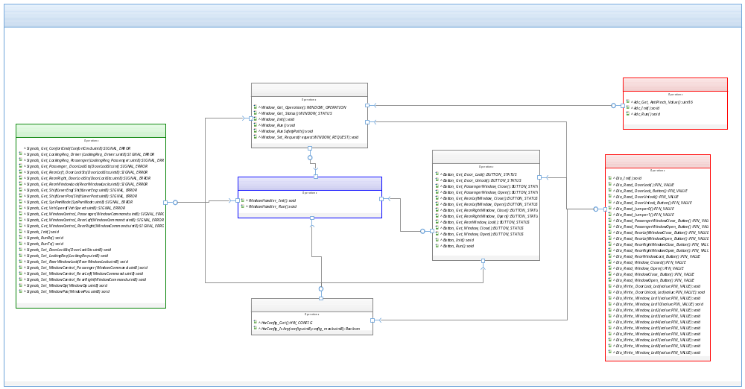

SW Component internal breakdown
The SWC WindowApp complexity is lower, so it is not necessary to perform any decomposition in subcomponents to deal with the complexity.

Functional Decomposition
WindowApp SWC will decompose in 5 functions to perform the functionalities described in requeriments allocation, as the next diagram show shows.
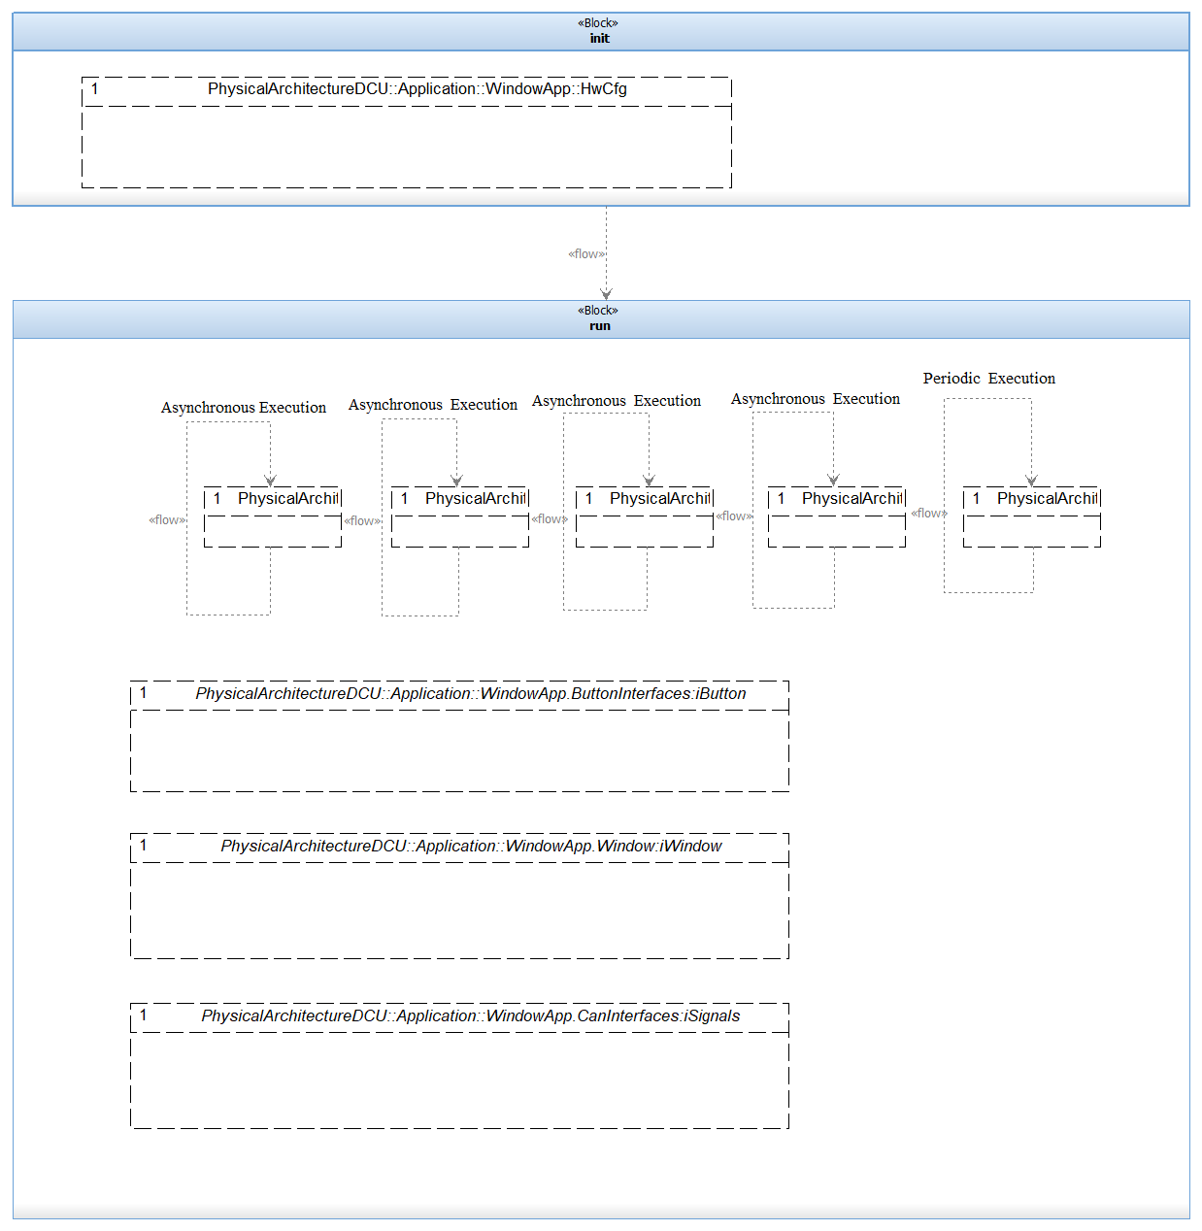
Function Description and Dynamic Behavior

Function void init (void)

Description | Interface function to perform WindowApp SWC initialization.
Parameter 1  <input> | void
Return Value | void
Precondition | The system needs to be runing.
Post condition | Execute the run function
Error Conditions | None
Requirements | None
Dynamic Behavior
Initialize the global and local variables to obtain the expect functionality and performance of the system. Ask to HwConfig to set up the required Hardware to perform all the functions in the SWC. Enable the global interrupts to handle the buttons events in the system.

Function void run (void)

Description | Interface function to perform WindowApp SWC Periodic Operations.
Parameter 1  <input> | void
Return Value | void
Precondition | The system must be running and the init function must have run without errors.
Post condition | None
Error Conditions | None
Requirements | None
Dynamic Behavior
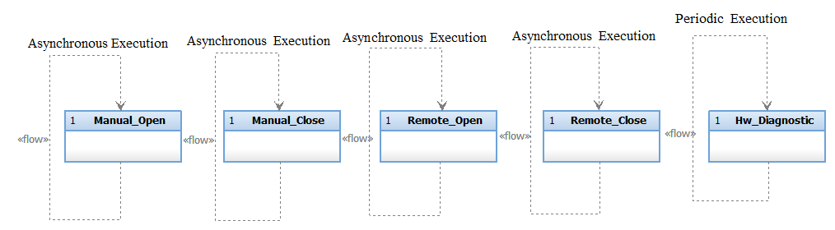

Function void Manual_Open (void)

Description | Contain the logic to open the Window
Parameter 1  <input> | void
Return Value | void
Precondition | The system needs to be runing.
Post condition | Execute the
Error Conditions | None
Requirements | DCU_SWR_39  DCU_SWR_40  DCU_SWR_41  DCU_SWR_42  DCU_SWR_71  DCU_SWR_73  DCU_SWR_75  DCU_SWR_77  DCU_SWR_79  DCU_SWR_81  DCU_SWR_83
Dynamic Behavior
When the button is pressed to open the window of the same button door, this task should be executed.
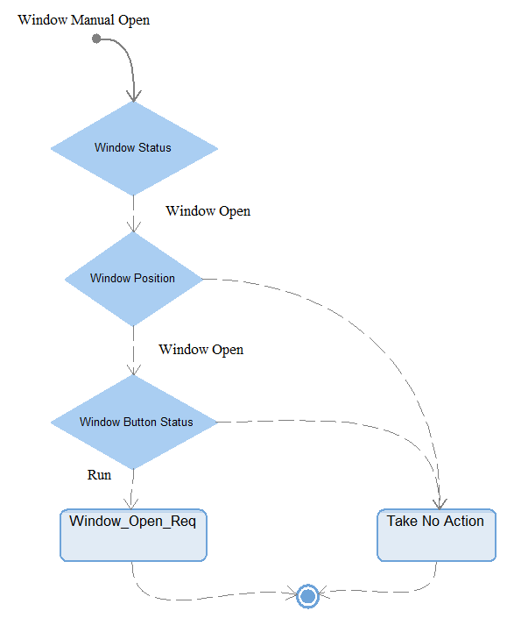

Function void Manual_Close (void)

Description | Contain the logic to close the Window
Parameter 1  <input> | void
Return Value | void
Precondition | The system needs to be running.
Post condition | None
Error Conditions | None
Requirements | DCU_SWR_50  DCU_SWR_53  DCU_SWR_54  DCU_SWR_55  DCU_SWR_56  DCU_SWR_72  DCU_SWR_74  DCU_SWR_76  DCU_SWR_78  DCU_SWR_80  DCU_SWR_82  DCU_SWR_84
Dynamic Behavior
When the button is pressed to close the window of the same button door, this task should be executed.
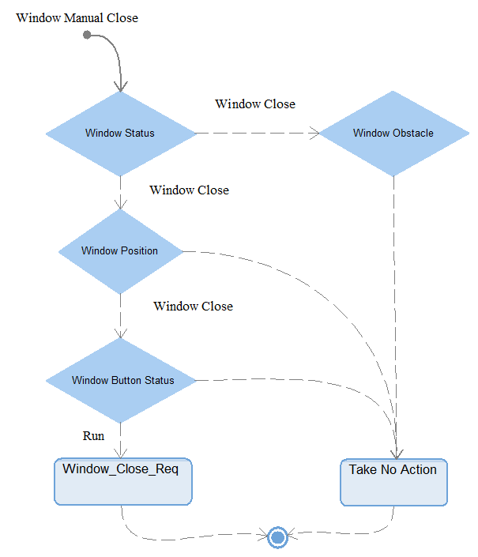

Function void Remote_Open (void)

Description | Contain the logic to open the Window when the instruction was generated remotely
Parameter 1  <input> | void
Return Value | void
Precondition | The system needs to be running.
Post condition | None
Error Conditions | None
Requirements | DCU_SWR_103  DCU_SWR_104  DCU_SWR_106  DCU_SWR_43  DCU_SWR_46  DCU_SWR_47  DCU_SWR_48  DCU_SWR_49  DCU_SWR_99  DCU_SWR_94  DCU_SWR_93  DCU_SWR_89  DCU_SWR_88
Dynamic Behavior
When the driver button is pressed to open any other window, this task must be executed.
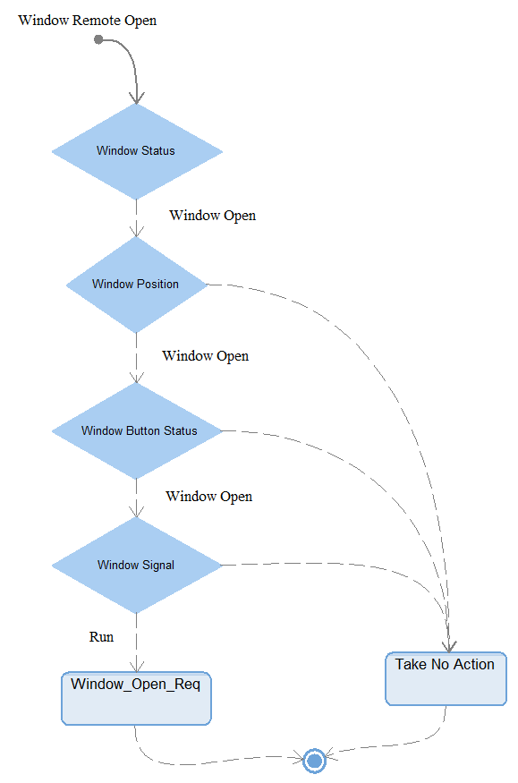

Function void Remote_Close (void)

Description | Contain the logic to close the Window when the instruction was generated remotely
Parameter 1  <input> | void
Return Value | void
Precondition | The system needs to be running.
Post condition | None
Error Conditions | None
Requirements | DCU_SWR_100  DCU_SWR_101  DCU_SWR_105  DCU_SWR_57  DCU_SWR_60  DCU_SWR_61  DCU_SWR_62  DCU_SWR_63  DCU_SWR_95  DCU_SWR_96  DCU_SWR_98  DCU_SWR_91  DCU_SWR_90
Dynamic Behavior
When the driver button is pressed to close any other window, this task must be executed.
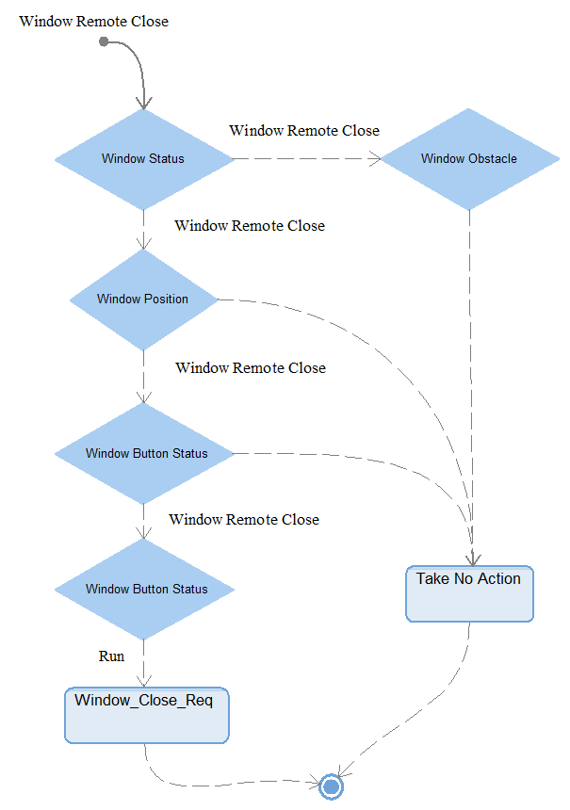

Function void Hw_Diagnotics (void)
Description | Contain the logic to Diagnostic the correct functionality of the Hardware, and the malfunction reports.
Parameter 1  <input| output| inout> | Contain the logic to close the Window when the instruction was generated remotely
Parameter 2..n | void
Return Value | void
Precondition | The system needs to be running.
Post condition | None
Error Conditions | HwDiagnostic Handler
Requirements | DCU_SWR_100  DCU_SWR_101  DCU_SWR_105  DCU_SWR_57  DCU_SWR_60  DCU_SWR_61  DCU_SWR_62  DCU_SWR_63  DCU_SWR_95  DCU_SWR_96  DCU_SWR_98  DCU_SWR_91  DCU_SWR_90

Dynamic Behavior
This task executes periodically to check the hardware’s correct function

